**Lab Guide**

Creating Reports in IBM RPA

Nigel T. Crowther

ncrowther@uk.ibm.com

Hands-on Lab

Version 1.0 for General Availability



NOTICES

This information was developed for products and services offered in the USA.

IBM may not offer the products, services, or features discussed in this document in other countries. Consult your local IBM representative for information on the products and services currently available in your area. Any reference to an IBM product, program, or service is not intended to state or imply that only that IBM product, program, or service may be used. Any functionally equivalent product, program, or service that does not infringe any IBM intellectual property right may be used instead. However, it is the user's responsibility to evaluate and verify the operation of any non-IBM product, program, or service.

IBM may have patents or pending patent applications covering subject matter described in this document. The furnishing of this document does not grant you any license to these patents. You can send license inquiries, in writing, to:

IBM Director of Licensing

IBM Corporation

North Castle Drive, MD-NC119

Armonk, NY 10504-1785

United States of America

The following paragraph does not apply to the United Kingdom or any other country where such provisions are inconsistent with local law: INTERNATIONAL BUSINESS MACHINES CORPORATION PROVIDES THIS PUBLICATION "AS IS" WITHOUT WARRANTY OF ANY KIND, EITHER EXPRESS OR IMPLIED, INCLUDING, BUT NOT LIMITED TO, THE IMPLIED WARRANTIES OF NON-INFRINGEMENT, MERCHANTABILITY OR FITNESS FOR A PARTICULAR PURPOSE. Some states do not allow disclaimer of express or implied warranties in certain transactions, therefore, this statement may not apply to you.

This information could include technical inaccuracies or typographical errors. Changes are periodically made to the information herein; these changes will be incorporated in new editions of the publication. IBM may make improvements and/or changes in the product(s) and/or the program(s) described in this publication at any time without notice.

Any references in this information to non-IBM websites are provided for convenience only and do not in any manner serve as an endorsement of those websites. The materials at those websites are not part of the materials for this IBM product and use of those websites is at your own risk.

IBM may use or distribute any of the information you supply in any way it believes appropriate without incurring any obligation to you.

Information concerning non-IBM products was obtained from the suppliers of those products, their published announcements or other publicly available sources. IBM has not tested those products and cannot confirm the accuracy of performance, compatibility or any other claims related to non-IBM products. Questions on the capabilities of non-IBM products should be addressed to the suppliers of those products.

This information contains examples of data and reports used in daily business operations. To illustrate them as completely as possible, the examples include the names of individuals, companies, brands, and products. All of these names are fictitious and any similarity to the names and addresses used by an actual business enterprise is entirely coincidental.

**TRADEMARKS**

IBM, the IBM logo, and ibm.com are trademarks or registered trademarks of International Business Machines Corp., registered in many jurisdictions worldwide. Other product and service names might be trademarks of IBM or other companies. A current list of IBM trademarks is available on the web at “Copyright and trademark information” at www.ibm.com/legal/copytrade.shtml.

Adobe, the Adobe logo, PostScript, and the PostScript logo are either registered trademarks or trademarks of Adobe Systems Incorporated in the United States, and/or other countries.

Cell Broadband Engine is a trademark of Sony Computer Entertainment, Inc. in the United States, other countries, or both and is used under license therefrom.

Intel, Intel logo, Intel Inside, Intel Inside logo, Intel Centrino, Intel Centrino logo, Celeron, Intel Xeon, Intel SpeedStep, Itanium, and Pentium are trademarks or registered trademarks of Intel Corporation or its subsidiaries in the United States and other countries.

IT Infrastructure Library is a Registered Trade Mark of AXELOS Limited.

ITIL is a Registered Trade Mark of AXELOS Limited.

Java and all Java-based trademarks and logos are trademarks or registered trademarks of Oracle and/or its affiliates.

Linear Tape-Open, LTO, the LTO Logo, Ultrium, and the Ultrium logo are trademarks of HP, IBM Corp. and Quantum in the U.S. and other countries.

Linux is a registered trademark of Linus Torvalds in the United States, other countries, or both.

Microsoft, Windows, Windows NT, and the Windows logo are trademarks of Microsoft Corporation in the United States, other countries, or both.

UNIX is a registered trademark of The Open Group in the United States and other countries.

© Copyright International Business Machines Corporation 2020.

This document may not be reproduced in whole or in part without the prior written permission of IBM.

US Government Users Restricted Rights - Use, duplication or disclosure restricted by GSA ADP Schedule Contract with IBM Corp.

**Table of Contents**

1 Introduction 4

1.1 What is Reporting? 4

1.2 Prerequisites 4

Scenario - Refund Receipt 5

1.3 Scenario Description 5

*1.3.1 Start RPA Studio* 5

1.3.2 Log In 6

1.3.3 Import Test Script 6

1.3.4 Customize the report 8

1.3.5 Create Parameters 9

1.3.6 Add Parameters to Report 9

1.3.7 Export Report 11

1.3.8 Select the Report Asset 12

1.3.9 Run the report 13

1.3.10 Add report to Refund Bot 14

1.3.11 Run Refunds 15

1.3.12 Conclusion 16

# Introduction

In this lab we will implement a refund report for the Refund bot from Lab 1.

The context of this lab is shown in the highlighted area below.

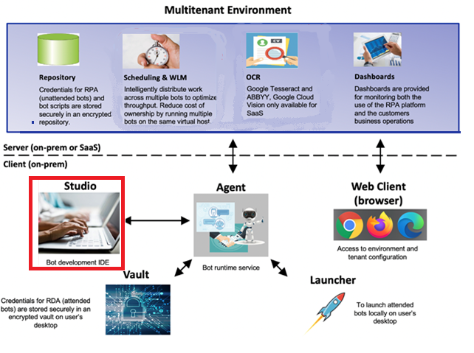

## What is Reporting?

Reports are created in RPA Studio. You create reports from data sources such as:

* Database
* Excel
* Parameters passed in from bot
* JSON

In this lab we will revisit the Refund Bot created in Lab 1. We will enhance the bot so that it creates a receipt in PDF format.

Note that this lab only touches the functionality of RPA reports. For detailed training see: <https://learn.ibm.com/course/view.php?id=8695>

## Prerequisites

IBM RPA Studio V21.0.2 or later.

# Scenario - Refund Receipt

We will create a refund receipt using the IBM RPA Reporting tool.

## Scenario Description

Rachel is an RPA developer responsible for building receipts. She is required to build this receipt:

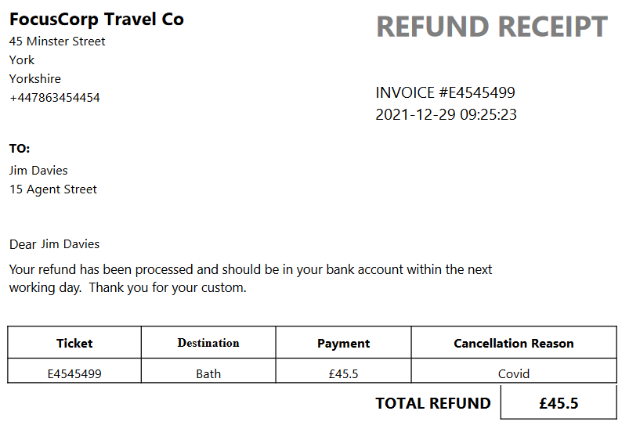

### Start RPA Studio

On your desktop find the IBM RPA Studio icon and launch it.

### Log In

Login to RPA Studio with your credentials. If you are using the SkyTap, the credentials are:

User: admin@ibmdba.com

Password: *passw0rd*

### Open the Test Script

Within RPA Studio, open *testReport*:

[bot_reporting_lab]\artefacts\testReport.wal

You should see the following. **Note:** the error is expected:

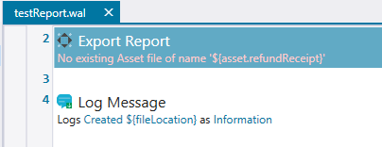

This script exports a report which we will create in the next step.

Within the *home* screen of RPA studio, select the *New* icon.

***Tip:*** *Select the upper part of the icon within the blank page.*

See below:

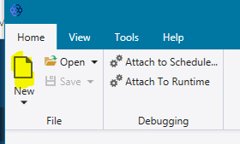

Select *Report File* and press *Create*:

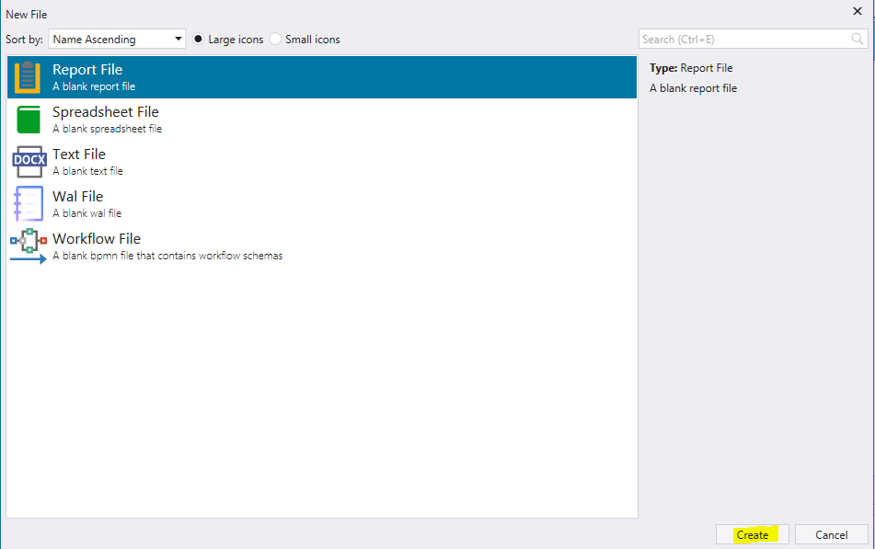

Now select *Template Report* and press *Next*

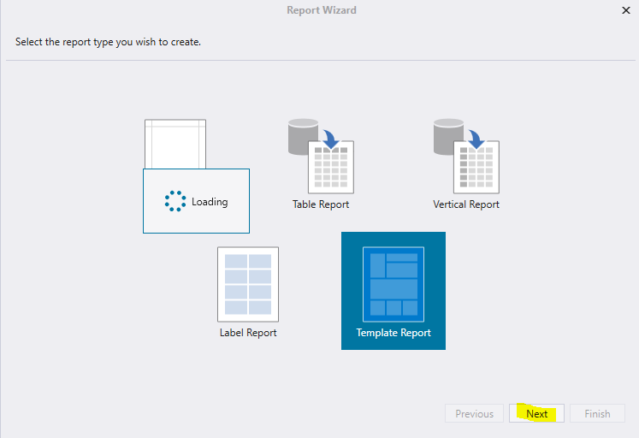

Select *Invoice 3* and press *Finish*

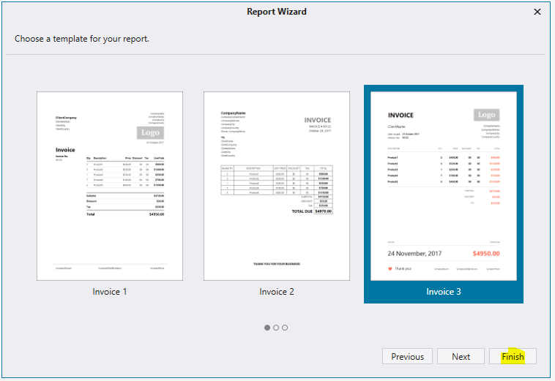

You should see the following:

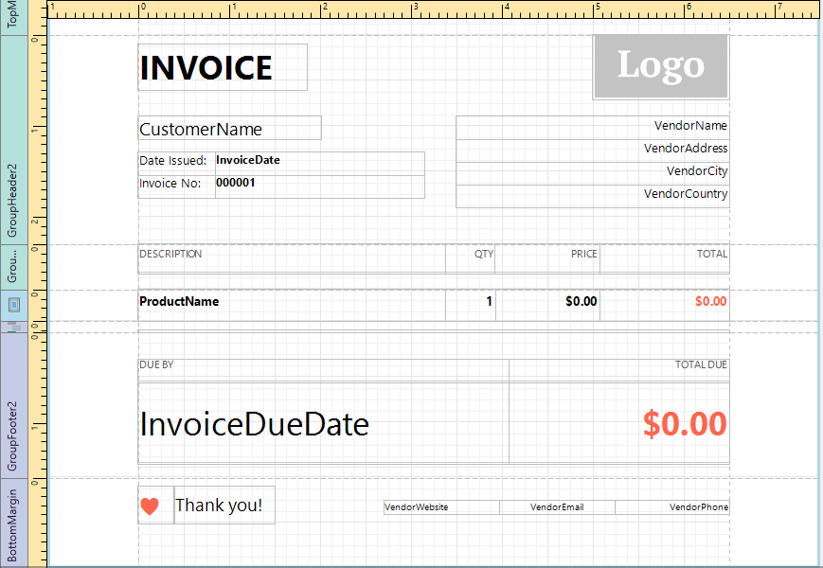

### Customize the report

Modify the report so that it looks like this:

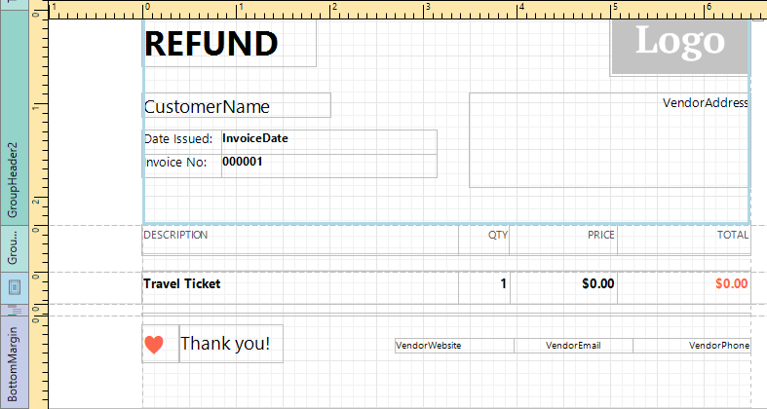

### Create Parameters

Now create parameters so the report can be regenerated for each customer.

Within the *Home* tab, click *Add Parameter*:

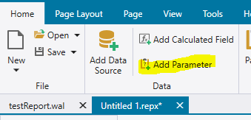

Add parameter *CustomerName*:

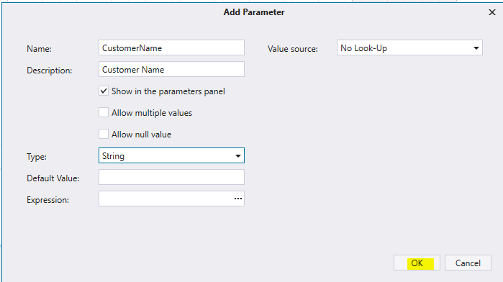

Repeat the above step to add the following parameters:

* InvoiceNumber
* Destination
* Amount
* RefundReason
* CustomerAddress

**Tip:** The exact spelling and case are important!

### Add Parameters to Report

Now modify the report so that it uses the parameters you’ve created. Start with *CustomerName*. Click on the *CustomerName* text in the reporting area. A small single chevron appears to the top right. Click it:

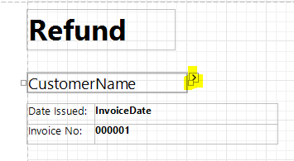

The *field* dialog box appears. Select *Expression*, then select down arrow and finally select *CustomerName*:

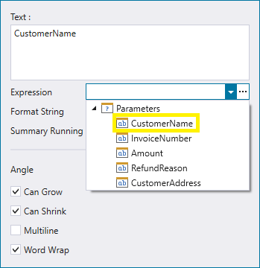

Repeat the above step for each parameter in the reporting area until your report looks like this:

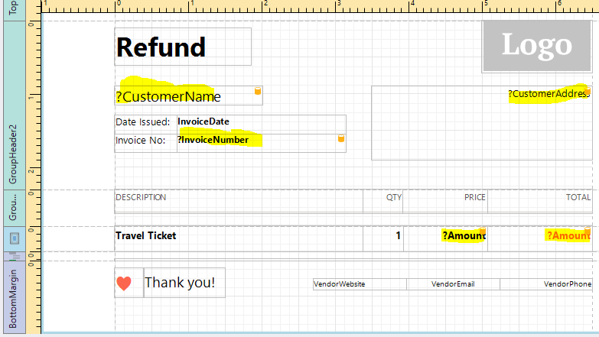

### Export Report

In the *Home* tab, press *Save*. A *Save As* dialog appears. Save the report into the existing *TestReport.wal.* **Important**. You must save the report into the existing script. By doing this, the report becomes an embedded asset within the script:

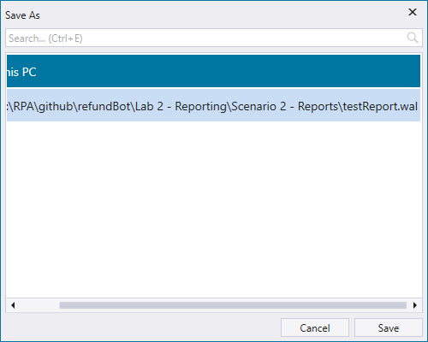

On pressing Save, you will be presented with the following dialog:

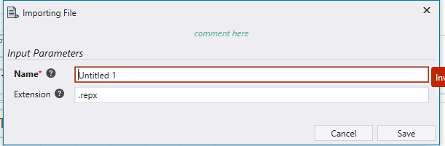

Create a name of *RefundReceipt* and press *Save*.

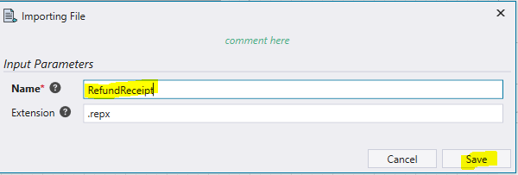

### Select the Report Asset

Select *testReport.wal*. Notice that the error has been fixed:

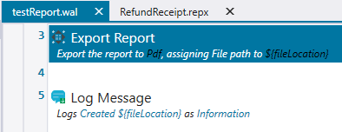

Enter *script* view to verify that the report is embedded as an asset. The asset is stored as encoded ASCII characters.

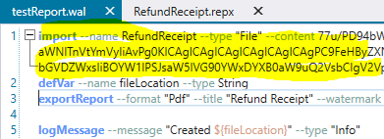

Back in Designer mode, edit the *Export Report* command. Verify that the parameters match those you created in the report:

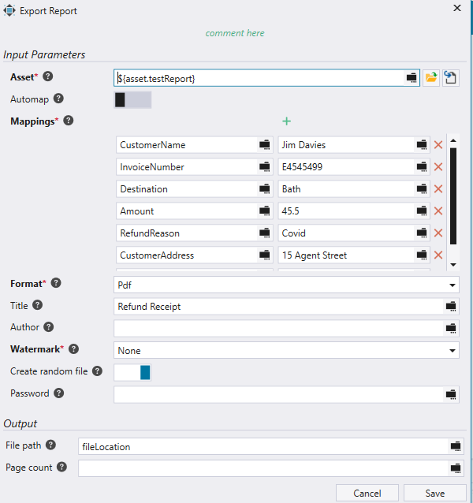

### Run the report

Now run the report (*Ctrl-F5*). In the Output tab you should see the name of the generated report:

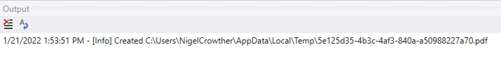

Open the PDF by copying and pasting its full path into a browser.

You should see the following report:

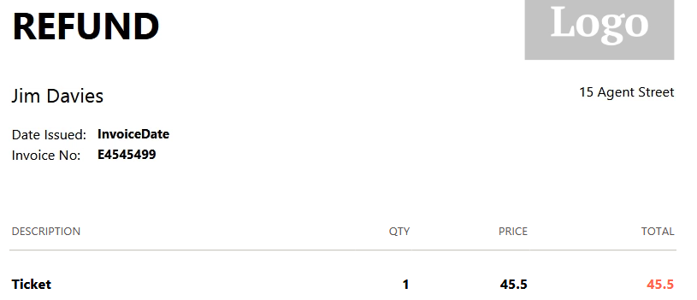

Notice the parameters passed from the *ExportReport* command are rendered in the generated report.

### Add report to Refund Bot

The final step is to add this report to the refund bot to create refund receipts.

Open the following script in RPA Studio:

[bot_design_lab]\artefacts\Refunds_Main_Complete.wal

Select the *Call Graph* tab. Double-click *SendCustomerReceipt*:

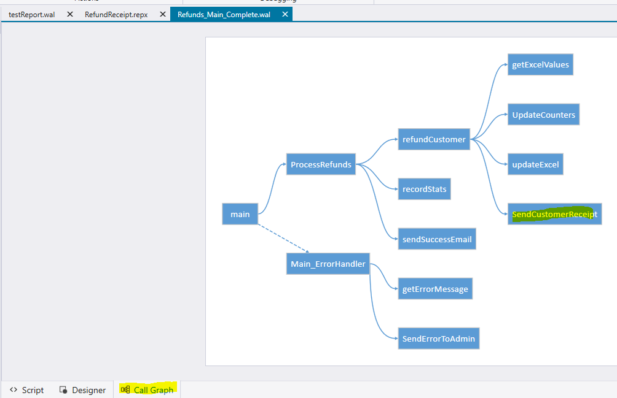

Within the *SendCustomerReceipt* subroutine, open the *Export Report* command. Verify the same parameters match your report:

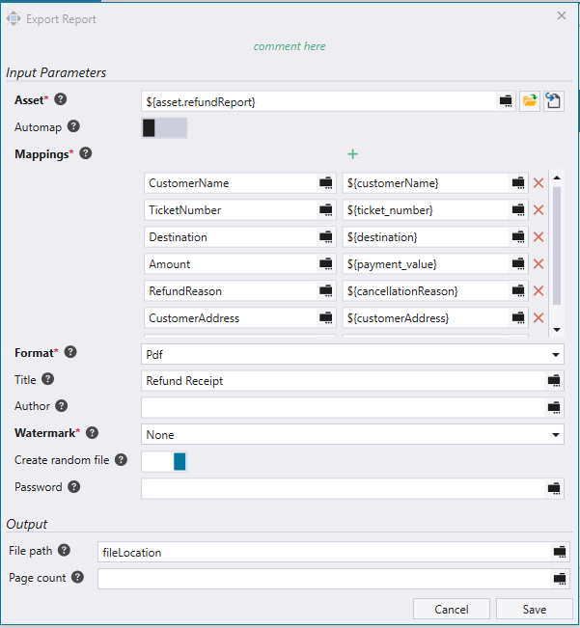

Notice the only difference between the parameters you created in your report and the ones here is *TicketNumber*. Change it to *InvoiceNumber* to match your report.



Now copy line 1 of *testReport.wal* to replace line 1 of *Refund_main_complete.wal*. This replaces the existing report asset with the one you created. **Tip:** It is easier to copy and paste within *Script* view.

On line 188 you will see an error – *No existing Asset file.* Edit the *Export Report* command to fix. Select the *RefundReceipt* asset as shown in the highlighted area below:

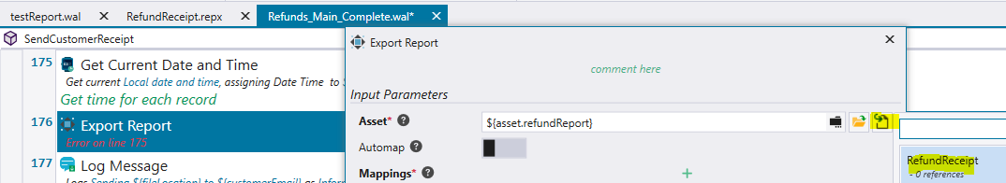

Press *Save*. The error should be fixed.

### Run Refunds

Hit *Ctrl-F5* to run the refunds bot. You should see each row in the excel read, and data entered to the website. Each time the script successfully refunds a customer, a refund receipt is generated.

**Tip:** If you see no refund receipts generated, then edit the customer excel file and reset the data back to its starting state.

On completion, the log output will look something like this:

[Info] Finding ticket P3B48847

[Info] Sending C:\temp\1\9a0fcd87-5d16-4886-b5d4-0129a53e0092.pdf to [KateyCrumble@talk21.com](mailto:KateyCrumble@talk21.com)

[Info] Create Email Body

[Info] Robot finished processing

Examine one of the reports generated. It should look like this:

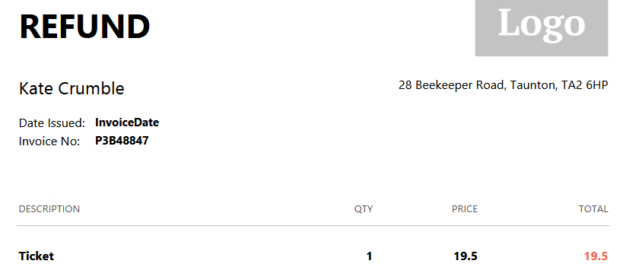

### Conclusion

We created a report in RPA studio then saved it as an asset inside a test script. Once tested, we copied this asset into our Refund bot. This enabled the refund bot to create refund receipts for each customer.

Nicely done! This concludes the lab.